Aireena Antony
DAF69 Batch

ASSIGNMENT – 3
DATA TRANSFORMATION & DATA MODELING
- Import “List of Orders.csv” into Power BI.
Select Get data and import text/csv data into Power BI.

- Open “List of Orders” in Power Query Editor by clicking on ‘Transform’.
Click on transform data while importing the data into Power BI.
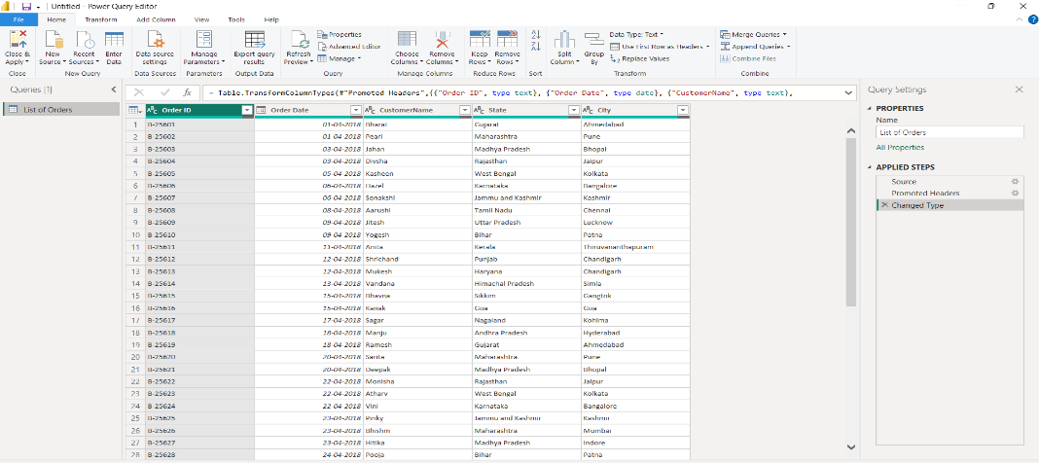

- Import “Order Details.csv” and “Sales target.csv” into Power Query Editor.
Click on transform data to enter into Power Query editor while importing the data into Power BI.
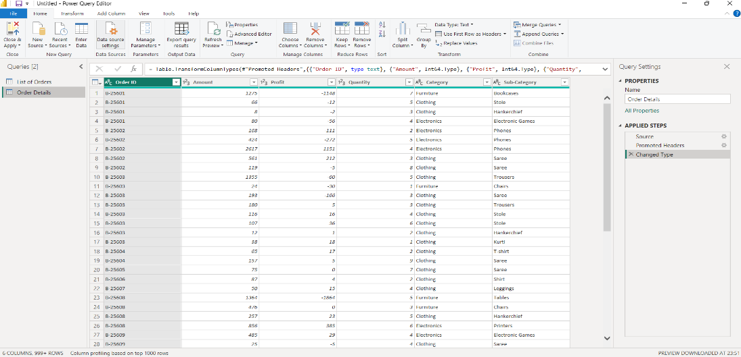

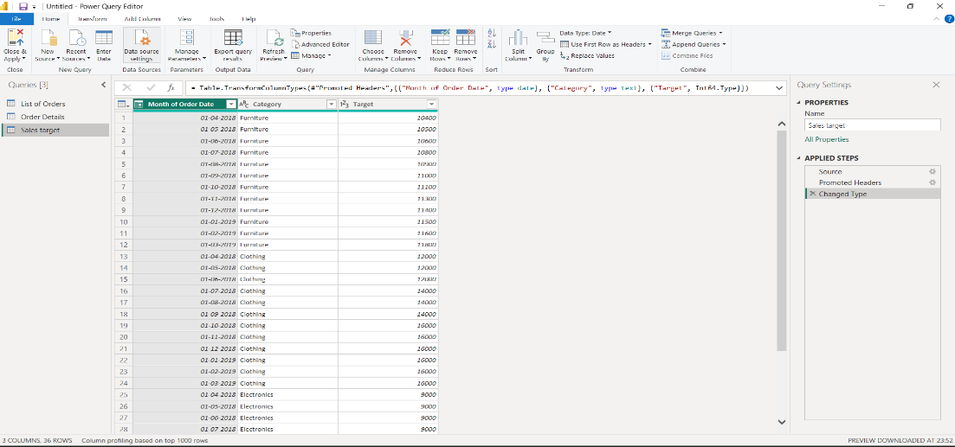
- Restrict the "List of Orders" table to only the first 500 rows.
Go to Home tab and select keep rows from reduce rows ribbon and enter the number of rows (500 rows) you want to keep.

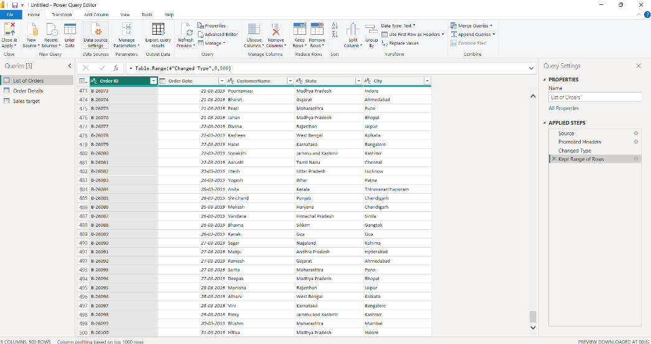
- Ensure the “Order Date” column in the “List of Orders” table is set to data type 'Date'.
Change the data type into ‘Date’ by selecting in the right corner of the column.
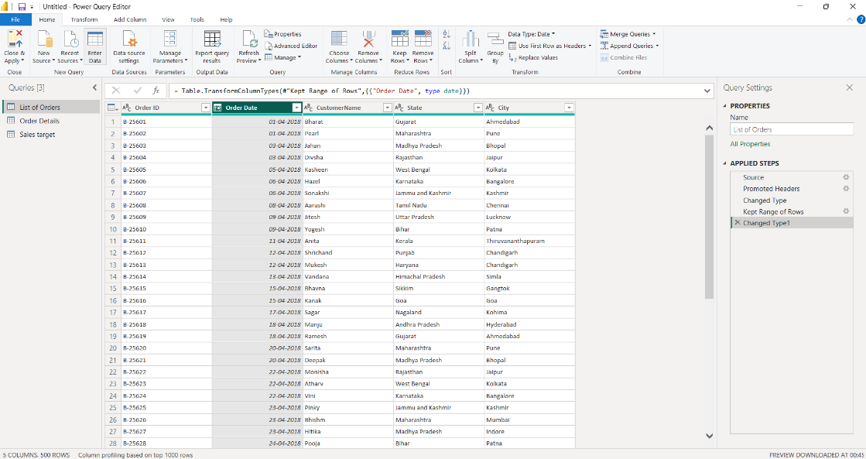

- Change the data type of “Amount” and “Target” columns to ‘Fixed Decimal Number’.
Change the data type into ‘Fixed Decimal number’ by selecting in the right corner of the column.
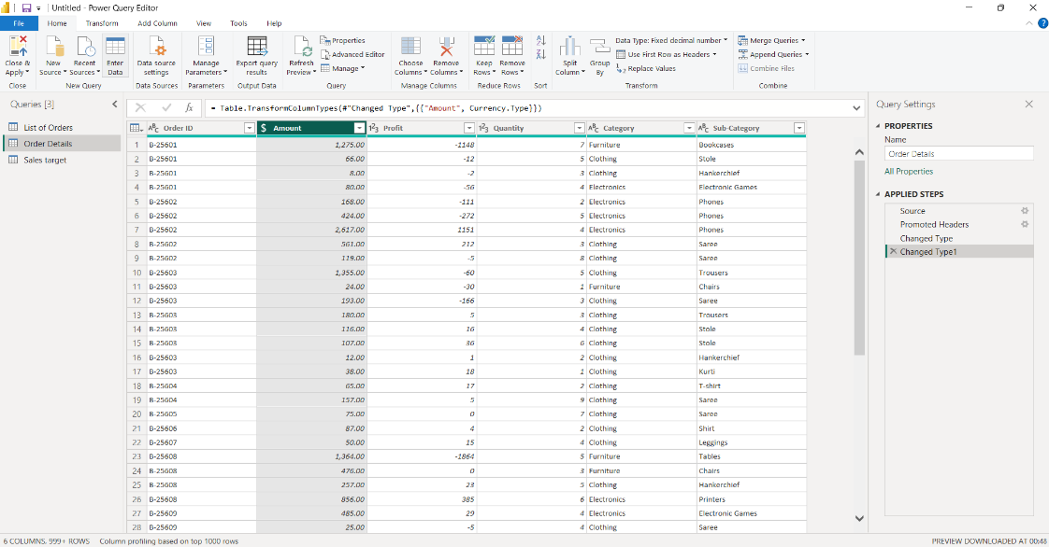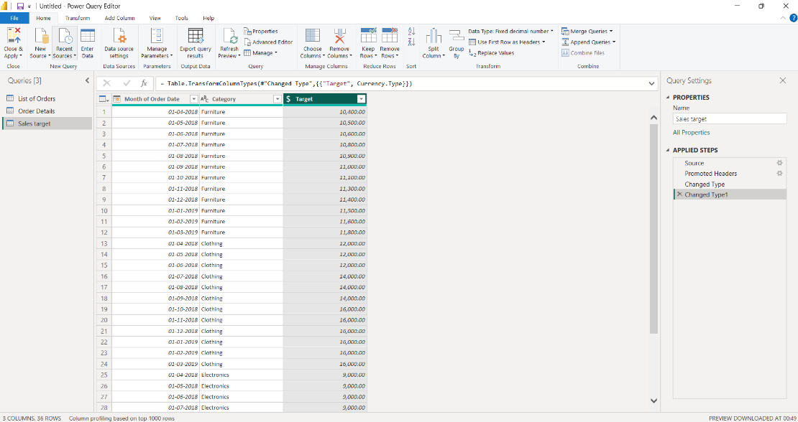
- Format the "CustomerName" column into proper case, ensuring consistent capitalization for each word.

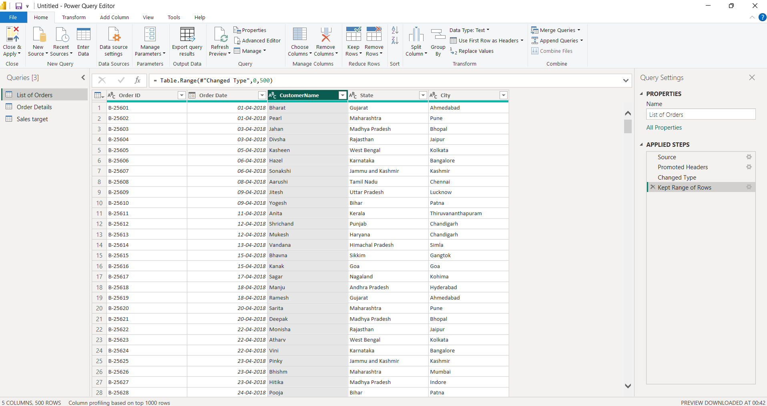

- Merge the "State" and "City" columns to create a new column named "Location" in the format ‘City, State’.
Select the columns for merging, then click on Merge column from text ribbon and select the separator for the column (comma) and enter the column name.
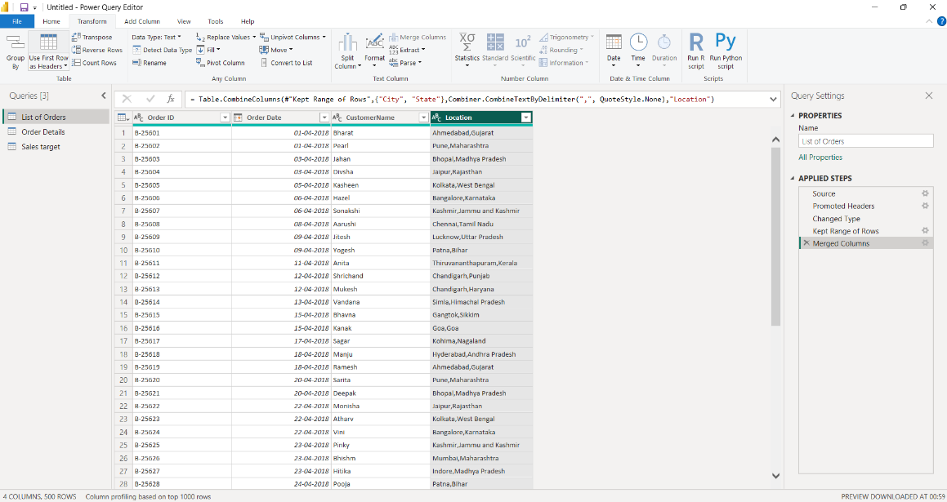
- Create a new custom column named "Profit Margin" as the percentage of "Profit" divided by "Amount".
Add a new column by clicking on custom column. Enter the new column name as ‘Profit Margin’ and enter the formula and change the data type into percentage.
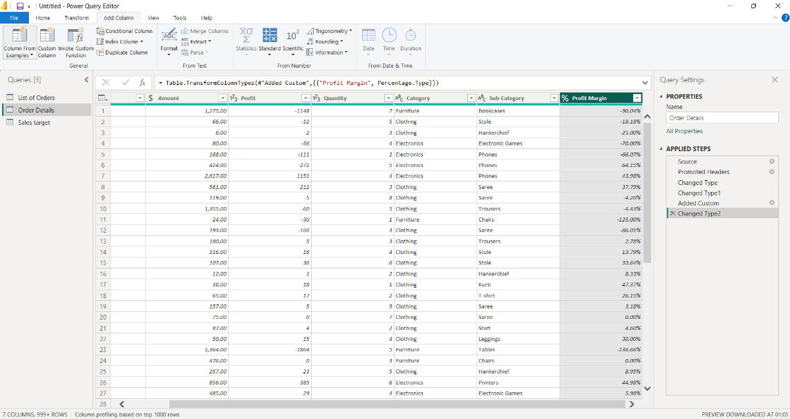

- Add a new conditional column named "Profit Status" based on the values in the "Profit" column. The conditions are as follows: if the profit is less than 0, the label should be "Loss"; if the profit equals 0, the label should be "Break-Even"; and if the profit is greater than 0, the label should be "Profit".

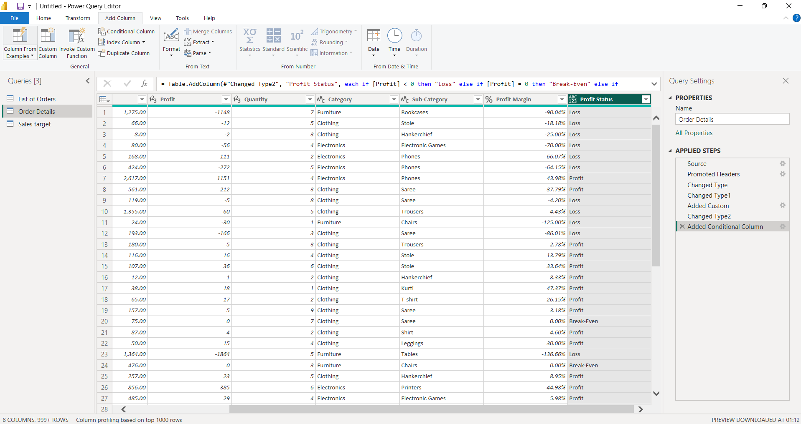

- Merge the "List of Orders" and "Order Details" tables into a new single table named "Orders Data" based on the "Order ID" relationship.

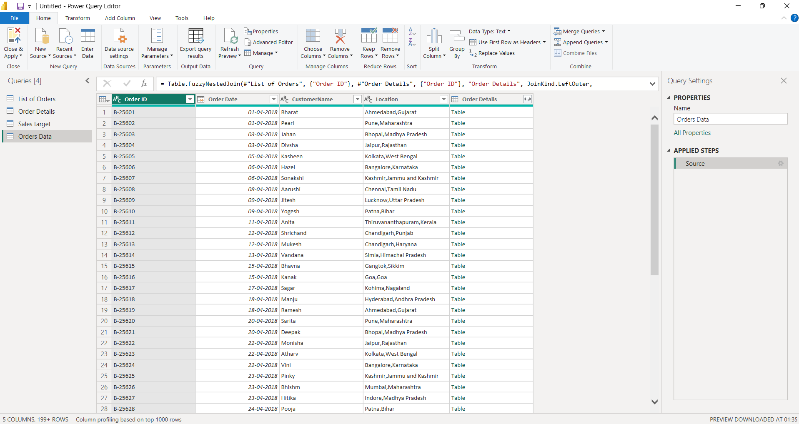
- Identify missing values in the data and determine a strategy to address them.
No missing values were found in this data. To handle missing values, we can use the method of finding average or by giving zero.

- Check for duplicate rows and define a strategy to handle duplicates.
No duplicate values found in the data set. To remove duplicate values, select the remove duplicates from the remove rows from reduce rows ribbon.

- In the ‘Orders Data’ table, utilize sorting and filtering techniques on columns like Order Date, State or Category to analyze data based on specific criteria:

◆ Sort the orders by Order Date in descending order to analyze recent trends.
◆ Filter the orders to focus only on a specific state (e.g., Tamil Nadu) for regional analysis.
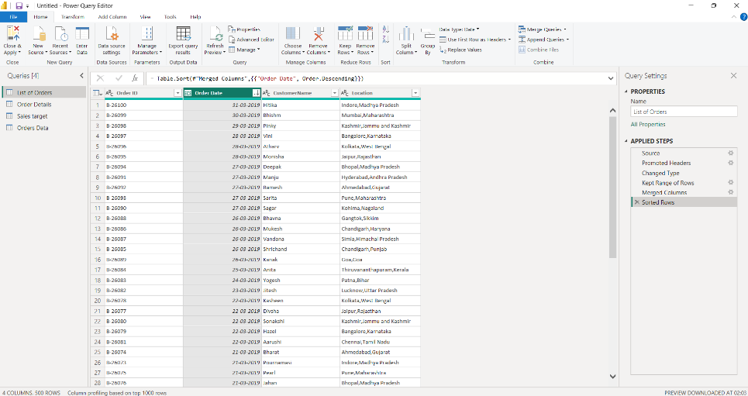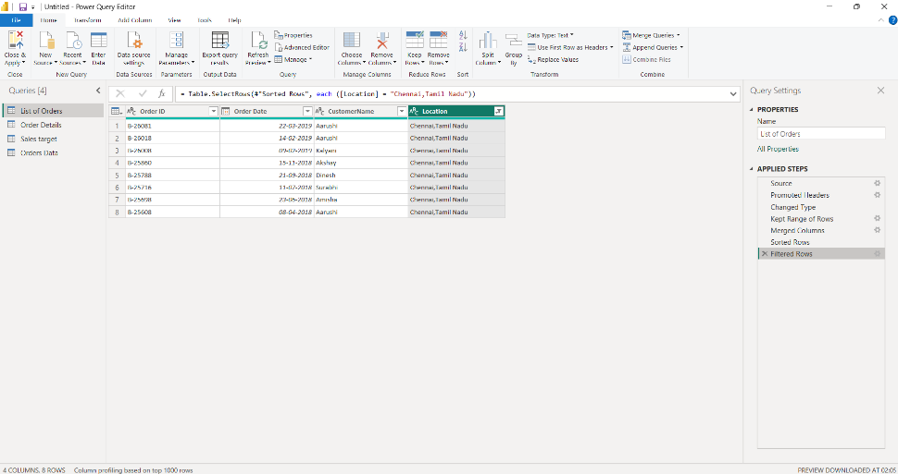

- Duplicate the “Order Details” table and calculate the count of each Order ID, average profit by Category or total amount by Sub-Category.

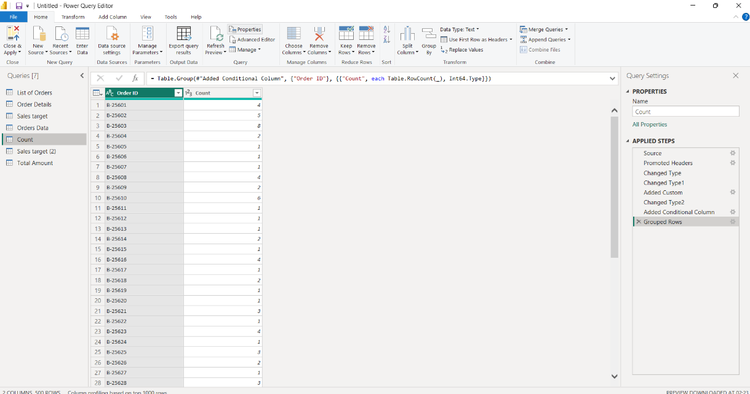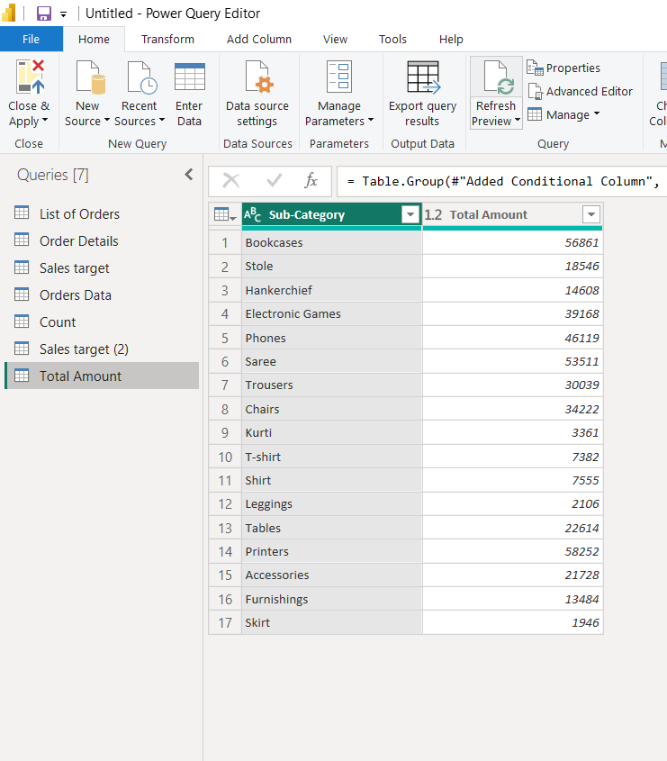
- Duplicate the “Sales Target” table and aggregate the total target amount by Month of Order Date.

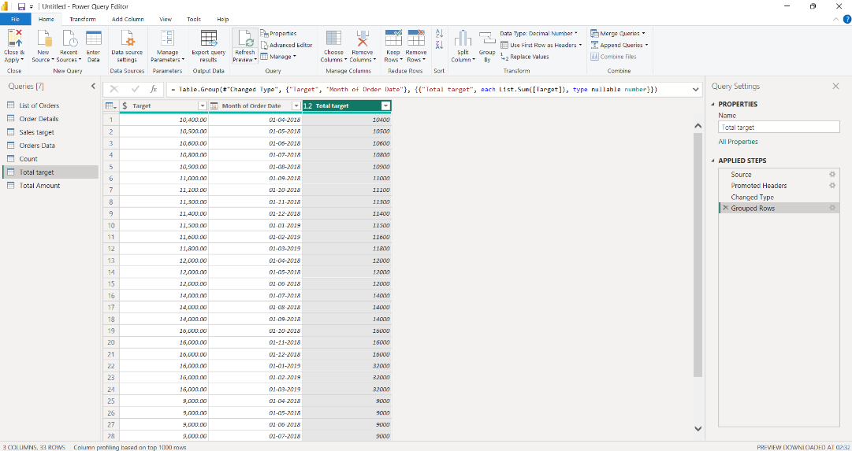

- Establish a relationship between the “List of Orders” and “Order Details” tables using the ‘Order ID’ column.

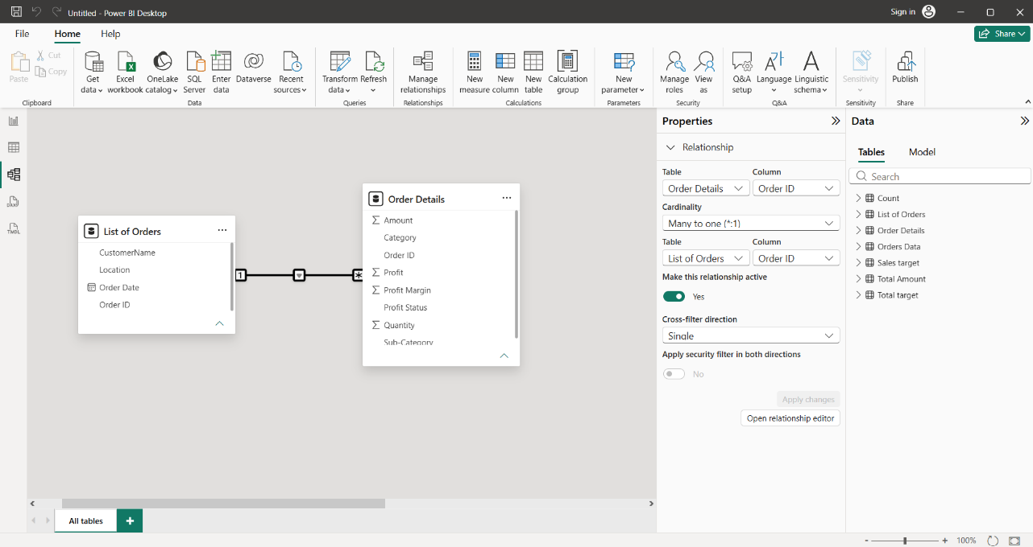
- Build a relationship between the “Order Details” and “Sales Target” tables based on the ‘Category’ column. Click "Manage relationships" and ensure this relationship is active.

